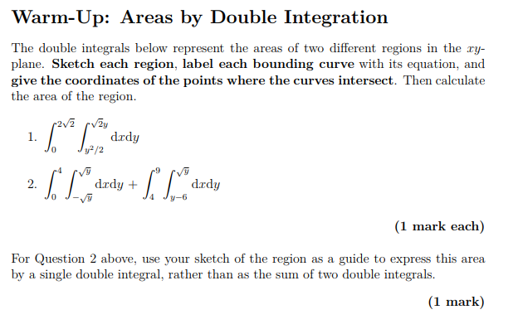**Solution**

1. Note that the boundaries of integration are

Expressing *y* in terms of *x* we get the two equations of curves

Let find the coordinates of the points where the curves intersect. For this we must solve the system of the equations

We get the next points and .

Let sketch each region for the double integral on the Graph1

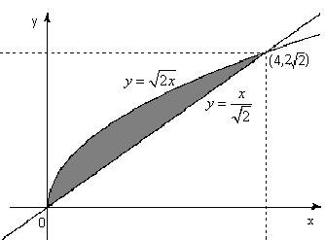

Graph1

According to the graph 1 find the area.

**Answer:**

2. Note that the boundaries of the first integration are

The boundaries of the second integration are

Expressing *y* in terms of *x* we get the two equations of curves

Let find the coordinates of the points where the curves intersect. For this we must solve the system of the equations

We get the next points and .

Let sketch each region for the double integral on the Graph2

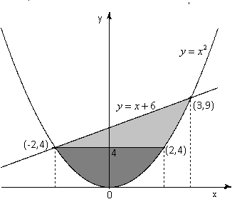

Graph2

According to the graph 1 find the area

Note that this calculation may be greatly simplified by reversing the order of integration:

**Answer:** .

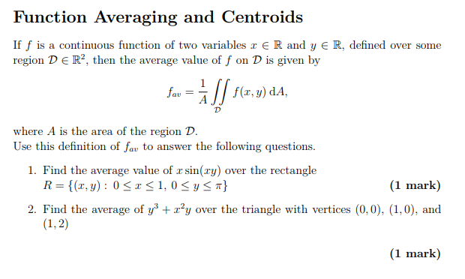 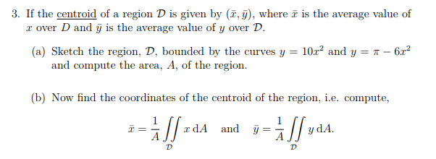

**Solution**

1. Let sketch the rectangle

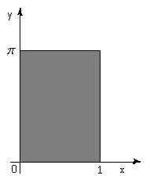

Graph 3

The area of the region is the area of the rectangle then

Using the formula find

**Answer:**

2. Let sketch the triangle with the vertices (0,0), (1,0) and (1,2).

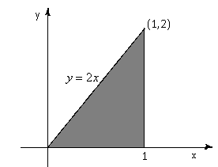

Graph 4

The area of the region is the area of the triangle then

Using the formula find

**Answer:** .

3 (a) Let find the coordinates of the points where the curves intersect. For this we must solve the system of the equations

Then

Let sketch the region, , bounded by the curves and

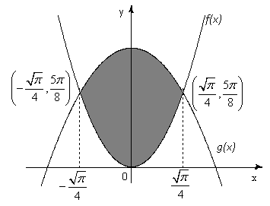

Graph 5

Let compute the area, A, of the region:

3 (b) Now find the coordinates of the centroid of the region, i.e. compute

**Answer**: centroid is at